Automated Employee Data Management System (HTML & CSS Based)
Abstract
The Automated Employee Data Management System is designed to streamline employee data handling using ServiceNow concepts such as Import Sets, Transform Maps, Dot Walking, and Dictionary Overrides. The system automates the process of importing, managing, and displaying employee information efficiently.
It reduces manual data entry, minimizes errors, and ensures real-time access to accurate employee details. The project demonstrates how ServiceNow functionalities can be used to build an efficient and structured data management system.
Introduction
In many organizations, employee data management involves manual processes or disconnected systems, which can lead to data inconsistencies and inefficiencies.
ServiceNow provides powerful tools to automate and manage data effectively.

Objectives:
- Automate employee data import using Import Sets
- Ensure structured data mapping using Transform Maps
- Retrieve related data using Dot Walking
- Customize field behavior using Dictionary Override
- Improve data accuracy and reduce manual effort

Literature Review
Traditional employee management systems rely heavily on manual input or full-stack applications with backend databases.
ServiceNow simplifies this process by offering built-in features such as:
- Import Sets for external data integration
- Transform Maps for field mapping
- Dot Walking for accessing related records
- Dictionary Overrides for customizing field behavior
These features help in:
- Reducing redundancy
- Improving data consistency
- Enabling real-time updates
- Enhancing system flexibility

Methodology
The project was developed using the following steps:
- Requirement Analysis
Identified required fields like name, ID, department, and salary.
- Data Import Design
Prepared external data source (CSV/Excel/XML) for employee record.
- Implementation in ServiceNow
- Import Set table creation
- Data loading into staging table
- Transform Map configuration
- Mapping to sys_user table

- Feature Implementation
- Dot Walking in Incident form
- Dictionary Override for Priority field

5. Testing
Verified data import, mapping accuracy, and real-time data retrieval.

Implementation
The system includes:
Features:
- Import Data from Data Source
- Dot Walking
- Dictionary Override
Styled UI with responsive design
Technologies Used:
- ServiceNow Platform
- Import Sets
- Transform Maps
- Incident & Task Tables
- JavaScript (for UI simulation if used)

Modules:
- Data Import Module
  - Handles external file upload
  - Maps data to system tables
- Data Retrieval Module
  - Uses Dot Walking for related data access
- Customization Module
  - Implements Dictionary Override

Code Used:
<!DOCTYPE html>
<html lang="en">
<head>
<meta charset="UTF-8">
<meta name="viewport" content="width=device-width, initial-scale=1.0">
<title>Employee Data Automation - Working Model</title>
<script src="https://cdn.tailwindcss.com"></script>
</head>
<body class="bg-gray-100 text-gray-800">

<!-- Navbar -->
<nav class="bg-white shadow-md p-4 flex justify-between">
<h1 class="font-bold text-xl">Employee Automation</h1>
</nav>

<!-- Hero -->
<section class="text-center py-10 bg-blue-600 text-white">
<h2 class="text-3xl font-bold">Working Model - ServiceNow Concepts</h2>
</section>

<!-- Upload Section (Import Set Simulation) -->
<section class="p-6 max-w-5xl mx-auto">
<h2 class="text-2xl font-semibold mb-4">Import Employee Data (CSV Simulation)</h2>
<input type="file" id="fileInput" class="mb-4" />
<button onclick="loadSample()" class="bg-blue-600 text-white px-4 py-2 rounded">Load Sample Data</button>
</section>

<!-- Employee Table -->
<section class="p-6 max-w-5xl mx-auto">
<h2 class="text-2xl font-semibold mb-4">Employee Records (sys_user)</h2>
<table class="w-full bg-white shadow rounded">
<thead class="bg-gray-200">
<tr>
<th class="p-2">Name</th>
<th>Email</th>
<th>Department</th>
<th>Manager</th>
</tr>
</thead>
<tbody id="tableBody"></tbody>
</table>
</section>

<!-- Dot Walking Simulation -->
<section class="p-6 max-w-5xl mx-auto">
<h2 class="text-2xl font-semibold mb-4">Dot Walking (Select Employee)</h2>
<select id="employeeSelect" class="p-2 border rounded"></select>
<div id="dotDetails" class="mt-4 p-4 bg-white shadow rounded"></div>
</section>

<!-- Dictionary Override -->
<section class="p-6 max-w-5xl mx-auto">
<h2 class="text-2xl font-semibold mb-4">Dictionary Override (Priority)</h2>
<p>Default Task Priority: <b>4 - Low</b></p>
<p>Incident Priority (Overridden): <b class="text-blue-600">3 - Moderate</b></p>
</section>

<script>
let employees = [];

// Sample Data (Simulates Import Set + Transform Map)
function loadSample() {
employees = [
{name: "Arun", email: "arun@mail.com", dept: "IT", manager: "Raj"},
{name: "Priya", email: "priya@mail.com", dept: "HR", manager: "Meena"},
{name: "Karthik", email: "karthik@mail.com", dept: "Finance", manager: "Suresh"}
];
renderTable();
populateDropdown();
}

// Render Table
function renderTable() {
const tbody = document.getElementById("tableBody");
tbody.innerHTML = "";

employees.forEach(emp => {
tbody.innerHTML += `
<tr class="text-center border-t">
<td class="p-2">${emp.name}</td>
<td>${emp.email}</td>
<td>${emp.dept}</td>
<td>${emp.manager}</td>
</tr>`;
});
}

// Dropdown for Dot Walking
function populateDropdown() {
const select = document.getElementById("employeeSelect");
select.innerHTML = "";

employees.forEach((emp, i) => {
select.innerHTML += `<option value="${i}">${emp.name}</option>`;
});

showDotWalking();
}

// Dot Walking Simulation
function showDotWalking() {
const index = document.getElementById("employeeSelect").value;
const emp = employees[index];

document.getElementById("dotDetails").innerHTML = `
<p><b>Email:</b> ${emp.email}</p>
<p><b>Department:</b> ${emp.dept}</p>
<p><b>Manager:</b> ${emp.manager}</p>
`;
}

document.getElementById("employeeSelect").addEventListener("change", showDotWalking);
</script>

</body>
</html>

Output:

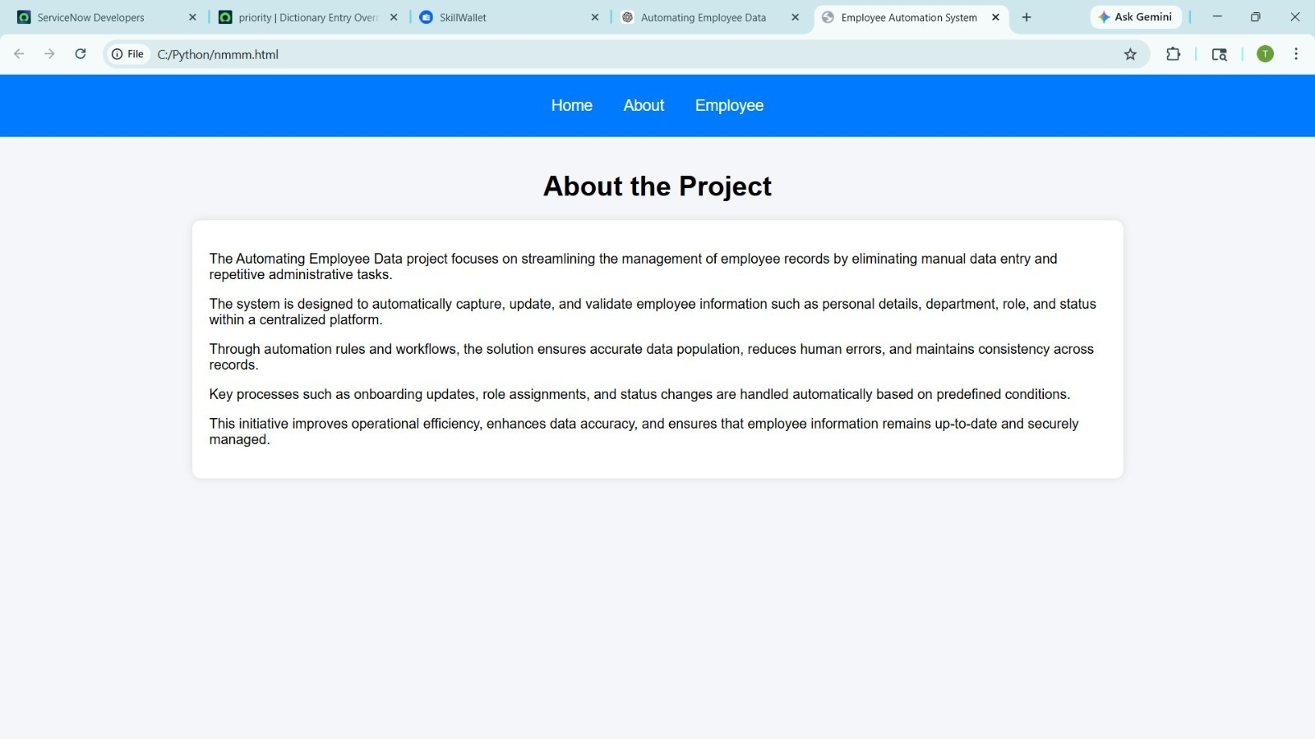

Results
The project successfully demonstrates:
- Automated employee data import process
- Accurate data mapping and integration
- Real-time retrieval of related data using Dot Walking
- Flexible field customization using Dictionary Override
- Reduction in manual effort and human errors

Conclusion
The project highlights how ServiceNow can be effectively used to automate employee data management. By using Import Sets, Dot Walking, and Dictionary Overrides, the system ensures efficiency, accuracy, and flexibility.
It provides a scalable solution that can be extended for enterprise-level applications.

Future Scope
- Integrate with real-time APIs
- Add workflow automation for approvals
- Implement role-based access control
- Develop full-stack UI dashboard
- Connect with external HR systems

References
- ServiceNow Documentation
- Import Sets and Transform Maps Guide
- ServiceNow Developer Portal
- W3Schools (for UI concepts)
- MDN Web Docs

